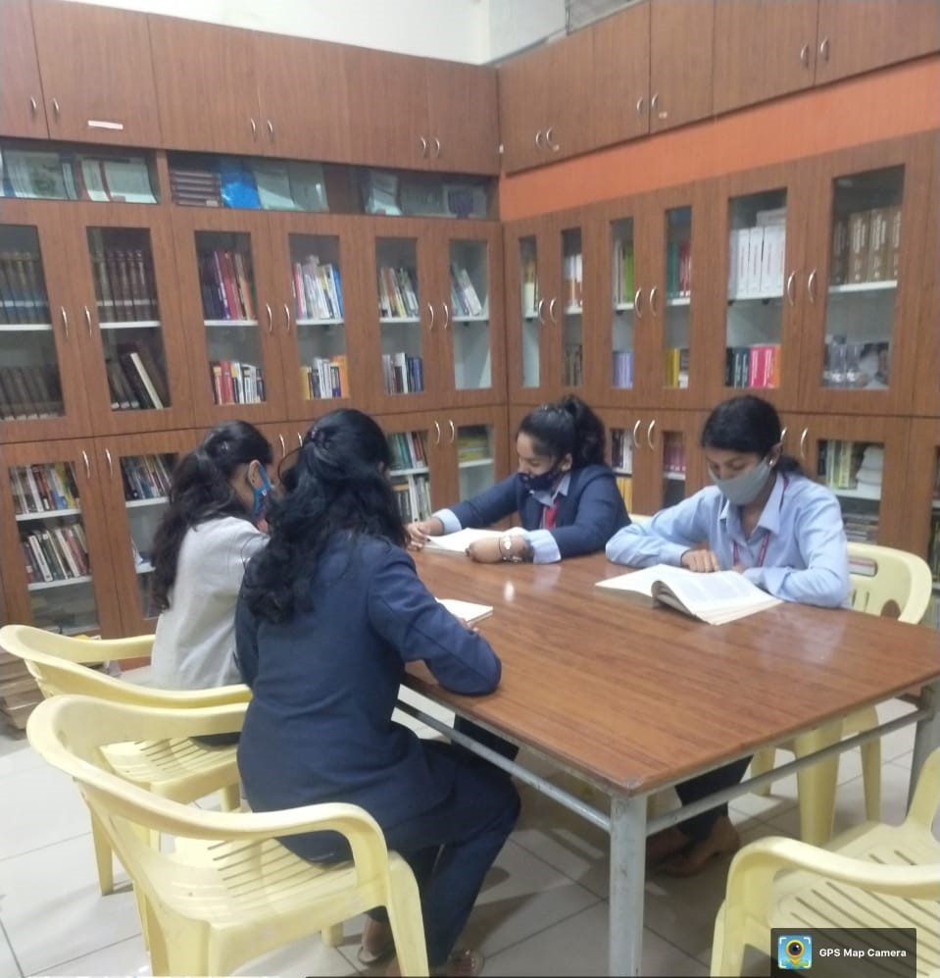

**PG UNIT**



**LIBRARY (CIRCULATION SECTION)**

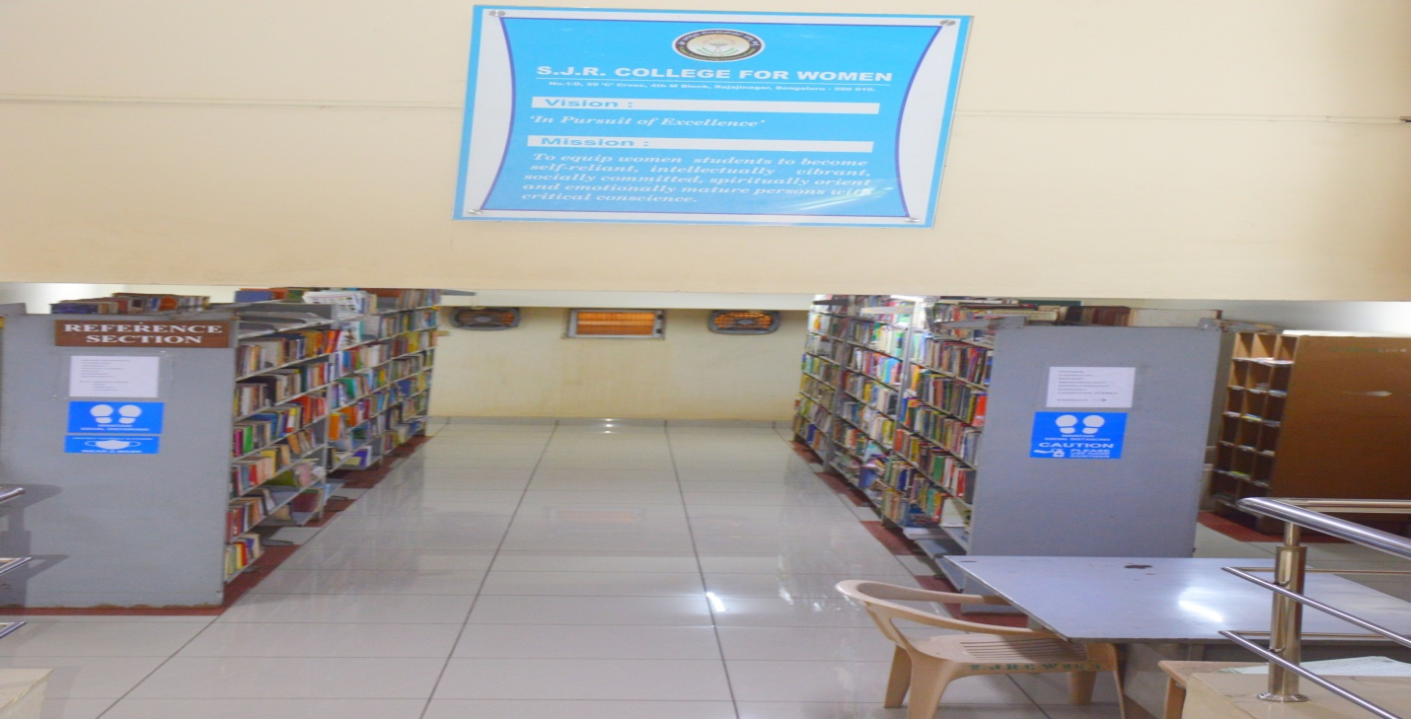

**REFERENCE SECTION**

**EASYLIB SOFTWARE**

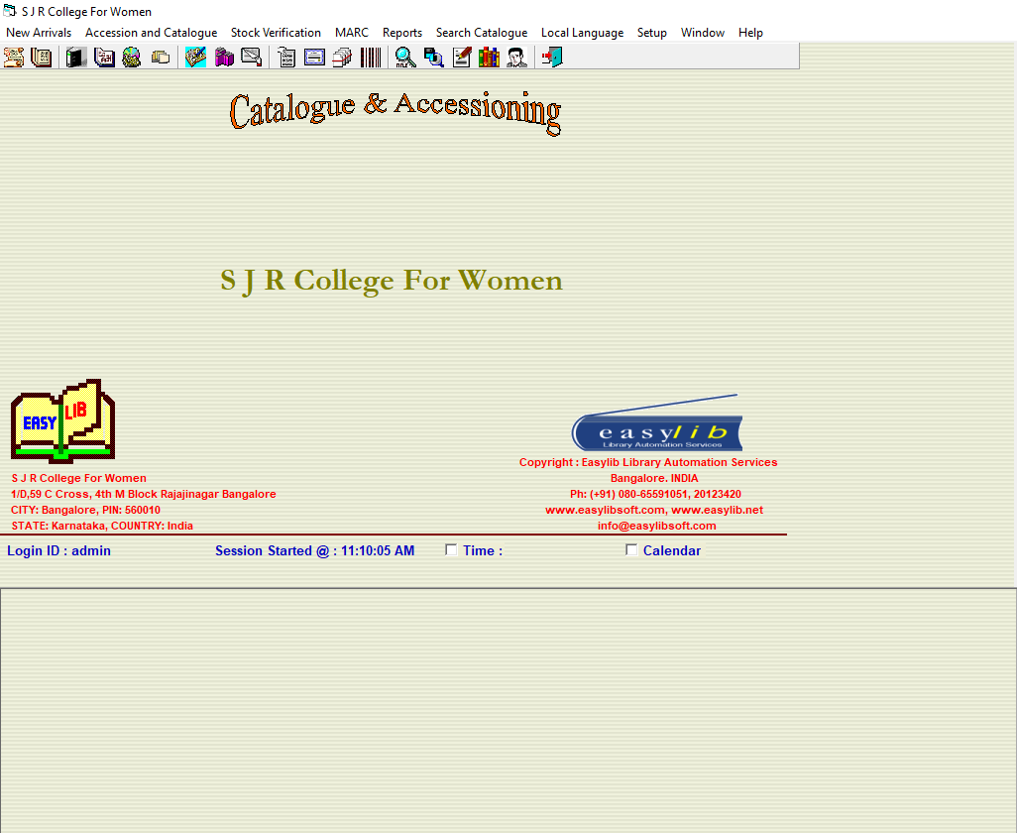

**SCREEN SHOT OF BOOKS ACCESSING MODULE**

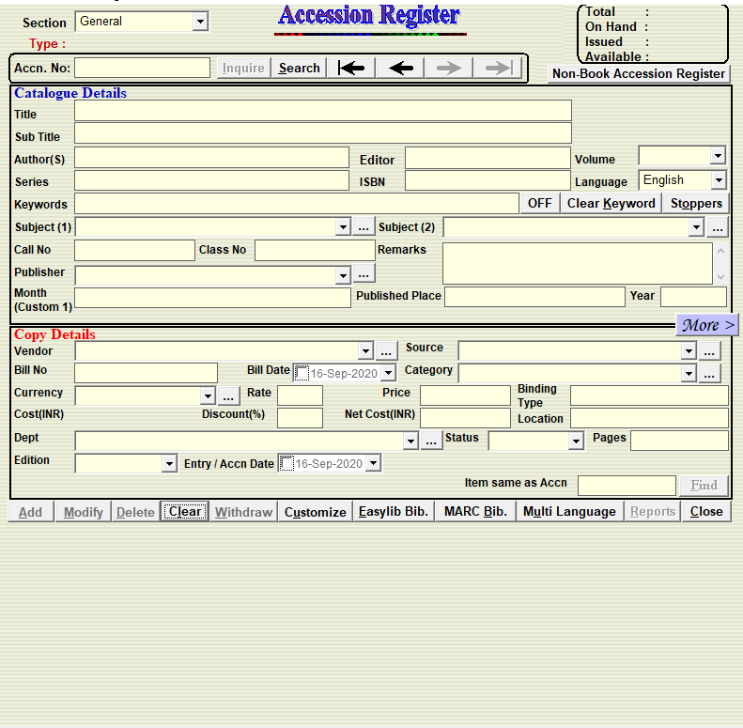

**SCREEN SHOT OF BOOKS ACCESSION USING EASYLIB SOFTWARE**

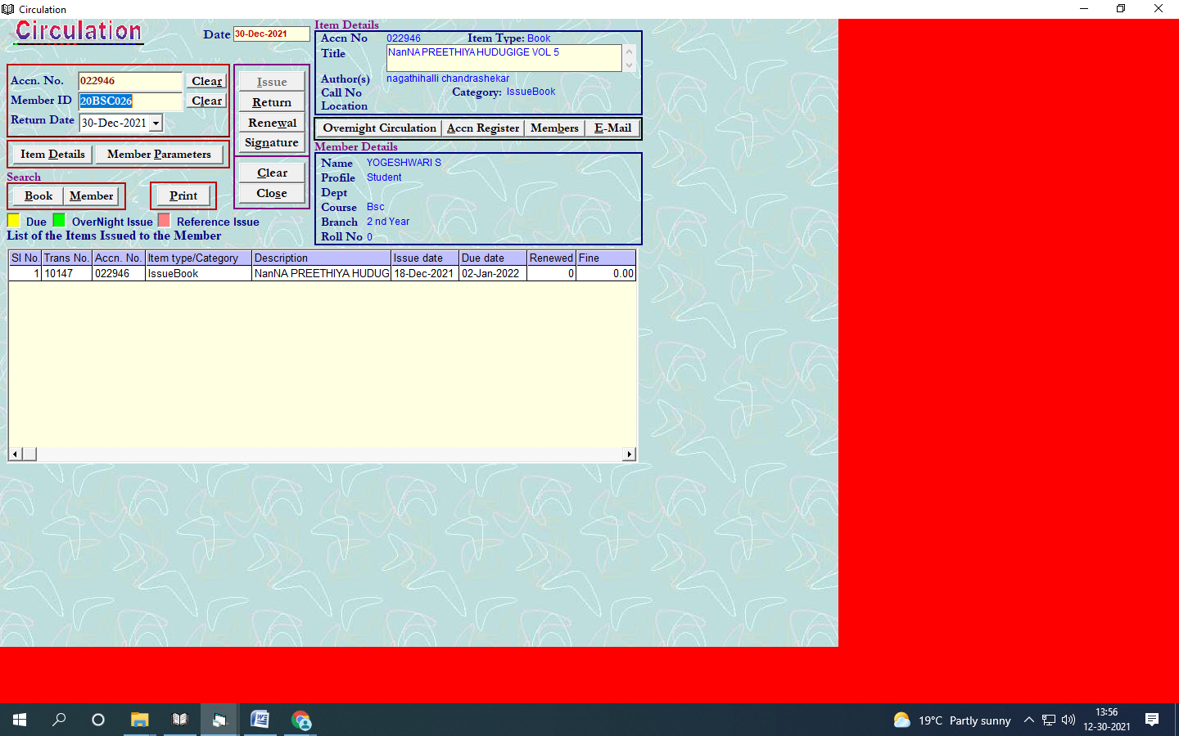

**CIRCULATION MODULE**